💡 **Question 1**

Convert 1D Array Into 2D Array

You are given a **0-indexed** 1-dimensional (1D) integer array original, and two integers, m and n. You are tasked with creating a 2-dimensional (2D) array with  m rows and n columns using **all** the elements from original.

The elements from indices 0 to n - 1 (**inclusive**) of original should form the first row of the constructed 2D array, the elements from indices n to 2 * n - 1 (**inclusive**) should form the second row of the constructed 2D array, and so on.

Return an m x n 2D array constructed according to the above procedure, or an empty 2D array if it is impossible.

**Example 1:** 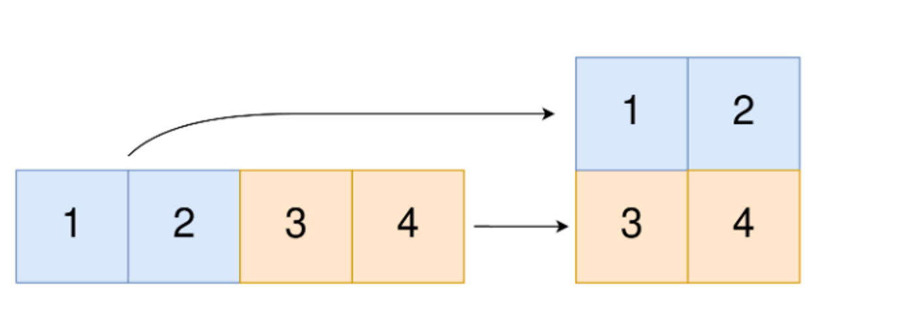

**Input:** original = [1,2,3,4], m = 2, n = 2

**Output:** [[1,2],[3,4]]

**Explanation:** The constructed 2D array should contain 2 rows and 2 columns.

The first group of n=2 elements in original, [1,2], becomes the first row in the constructed 2D array.

The second group of n=2 elements in original, [3,4], becomes the second row in the constructed 2D array.

***Solution -***

def convert_to_2d(original, m, n):

    if m * n != len(original):

        return []  # Impossible to construct 2D array

    result = []

    for i in range(0, len(original), n):

        result.append(original[i:i+n])

    return result

original = [1, 2, 3, 4]

m = 2

n = 2

print(convert_to_2d(original, m, n))

💡 **Question 2**

You have n coins and you want to build a staircase with these coins. The staircase consists of k rows where the ith row has exactly i coins. The last row of the staircase **may be** incomplete.

Given the integer n, return the number of ***complete rows*** of the staircase you will build.

**Example 1:**



**Input:** n = 5

**Output:** 2

**Explanation:** Because the 3rd row is incomplete, we return 2.

***Solution -***

def arrangeCoins(n):

    left, right = 0, n

    while left <= right:

        mid = (left + right) // 2

        total = (mid * (mid + 1)) // 2

        if total <= n:

            left = mid + 1

        else:

            right = mid - 1

    return right

print(arrangeCoins(5))

💡 **Question 3**

Given an integer array nums sorted in **non-decreasing** order, return an array of ***the squares of each number*** sorted in non-decreasing order.

**Example 1:**

**Input:** nums = [-4,-1,0,3,10]

**Output:** [0,1,9,16,100]

**Explanation:** After squaring, the array becomes [16,1,0,9,100].

After sorting, it becomes [0,1,9,16,100].

***Solution -***

nums = [-4, -1, 0, 3, 10]

def sortedSquares(nums):

    n = len(nums)

    result = [0] * n

    left, right = 0, n - 1

    idx = n - 1

    while left <= right:

        if abs(nums[left]) >= abs(nums[right]):

            result[idx] = nums[left] * nums[left]

            left += 1

        else:

            result[idx] = nums[right] * nums[right]

            right -= 1

        idx -= 1

    return result

print(sortedSquares(nums))

💡 **Question 4**

Given two **0-indexed** integer arrays nums1 and nums2, return *a list* answer *of size* 2 *where:*

* answer[0] *is a list of all* ***distinct*** *integers in* nums1 *which are* ***not*** *present in* nums2*.*
* answer[1] *is a list of all* ***distinct*** *integers in* nums2 *which are* ***not*** *present in* nums1.

**Note** that the integers in the lists may be returned in **any** order.

**Example 1:**

**Input:** nums1 = [1,2,3], nums2 = [2,4,6]

**Output:** [[1,3],[4,6]]

**Explanation:**

For nums1, nums1[1] = 2 is present at index 0 of nums2, whereas nums1[0] = 1 and nums1[2] = 3 are not present in nums2. Therefore, answer[0] = [1,3].

For nums2, nums2[0] = 2 is present at index 1 of nums1, whereas nums2[1] = 4 and nums2[2] = 6 are not present in nums2. Therefore, answer[1] = [4,6].

***Solution -***

def findMissingElements(nums1, nums2):

    set1 = set(nums1)

    set2 = set(nums2)

    answer1 = [num for num in set1 if num not in set2]

    answer2 = [num for num in set2 if num not in set1]

    return [answer1, answer2]

nums1 = [1, 2, 3]

nums2 = [2, 4, 6]

print(findMissingElements(nums1, nums2))

💡 **Question 5**

Given two integer arrays arr1 and arr2, and the integer d, return the distance value between the two arrays.

The distance value is defined as the number of elements arr1[i] such that there is not any element arr2[j] where |arr1[i]-arr2[j]| <= d.

**Example 1:**

**Input:** arr1 = [4,5,8], arr2 = [10,9,1,8], d = 2

**Output:** 2

**Explanation:**

For arr1[0]=4 we have:

|4-10|=6 > d=2

|4-9|=5 > d=2

|4-1|=3 > d=2

|4-8|=4 > d=2

For arr1[1]=5 we have:

|5-10|=5 > d=2

|5-9|=4 > d=2

|5-1|=4 > d=2

|5-8|=3 > d=2

For arr1[2]=8 we have:

**|8-10|=2 <= d=2**

**|8-9|=1 <= d=2**

|8-1|=7 > d=2

**|8-8|=0 <= d=2**

***Solution -***

def findDistanceValue(arr1, arr2, d):

    distance = 0

    for num1 in arr1:

        for num2 in arr2:

            if abs(num1 - num2) <= d:

                break

        else:

            distance += 1

    return distance

arr1 = [4, 5, 8]

arr2 = [10, 9, 1, 8]

d = 2

print(findDistanceValue(arr1, arr2, d))

💡 **Question 6**

Given an integer array nums of length n where all the integers of nums are in the range [1, n] and each integer appears **once** or **twice**, return an array of all the integers that appears ***twice***.

You must write an algorithm that runs in O(n) time and uses only constant extra space.

**Example 1:**

**Input:** nums = [4,3,2,7,8,2,3,1]

**Output:**

[2,3]

***Solution -***

nums = [4, 3, 2, 7, 8, 2, 3, 1]

def findDuplicates(nums):

    result = []

    for num in nums:

        if nums[abs(num) - 1] > 0:

            nums[abs(num) - 1] *= -1

        else:

            result.append(abs(num))

    return result

print(findDuplicates(nums))

💡 **Question 7**

Suppose an array of length n sorted in ascending order is **rotated** between 1 and n times. For example, the array nums = [0,1,2,4,5,6,7] might become:

* [4,5,6,7,0,1,2] if it was rotated 4 times.
* [0,1,2,4,5,6,7] if it was rotated 7 times.

Notice that **rotating** an array [a[0], a[1], a[2], ..., a[n-1]] 1 time results in the array [a[n-1], a[0], a[1], a[2], ..., a[n-2]].

Given the sorted rotated array nums of **unique** elements, return *the minimum element of this array*.

You must write an algorithm that runs in O(log n) time.

**Example 1:**

**Input:** nums = [3,4,5,1,2]

**Output:** 1

**Explanation:**

The original array was [1,2,3,4,5] rotated 3 times.

***Solution -***

def findMin(nums):

    left = 0

    right = len(nums) - 1

    if nums[left] < nums[right]:

        return nums[left]

    while left < right:

        mid = (left + right) // 2

        if nums[mid] > nums[right]:

            left = mid + 1

        else:

            right = mid

    return nums[left]

nums = [3, 4, 5, 1, 2]

print(findMin(nums))

💡 **Question 8**

An integer array original is transformed into a **doubled** array changed by appending **twice the value** of every element in original, and then randomly **shuffling** the resulting array.

Given an array changed, return original *if* changed *is a* ***doubled*** *array. If* changed *is not a* ***doubled*** *array, return an empty array. The elements in* original *may be returned in* ***any*** *order*.

**Example 1:**

**Input:** changed = [1,3,4,2,6,8]

**Output:** [1,3,4]

**Explanation:** One possible original array could be [1,3,4]:

* Twice the value of 1 is 1 * 2 = 2.
* Twice the value of 3 is 3 * 2 = 6.
* Twice the value of 4 is 4 * 2 = 8.

Other original arrays could be [4,3,1] or [3,1,4].

***Solution -***

from collections import defaultdict

def findOriginalArray(changed):

    count = defaultdict(int)

    for num in changed:

        count[num] += 1

    original = []

    for num in changed:

        if count[num] == 0:

            continue

        if count[2 * num] == 0:

            return []

        count[num] -= 1

        count[2 * num] -= 1

        original.append(num)

    if len(original) == len(changed) // 2:

        return original

    else:

        return []

changed = [1, 3, 4, 2, 6, 8]

print(findOriginalArray(changed))